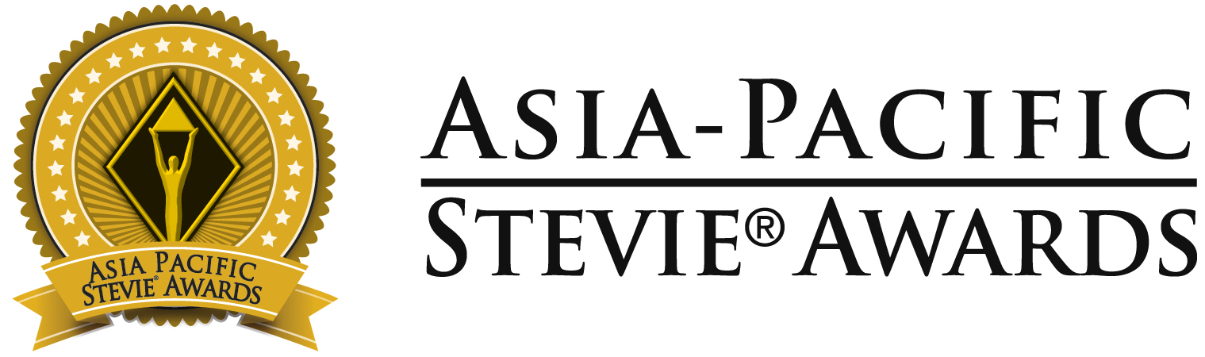

Below are optional phrases for your organization to use on social media to share the news of your Stevie Award(s).
Please tag us in your social posts as you see fit. We encourage you to follow our pages – we post features on Stevie winners throughout the year.
The Asia-Pacific Stevie Awards links: Facebook | Instagram | Twitter | LinkedIn| YouTube

Facebook, Instagram, LinkedIn Post Option 1:

[ORGANIZATION NAME/YOUR NAME] has been recognized as a [Gold, Silver, or Bronze] winner in the 10th annual @Asia-Pacific Stevie Awards

The 2023 competition received more than 800 nominations from 20 nations. It’s an honor to join the list of prestigious #StevieAward winners. View the full list of winners: [LINK TO WINNERS PAGE or Your Own Press Release]
#TheStevieAwards #StevieWinner2023

Facebook, Instagram, LinkedIn Post Option 2:

It’s an honor to be recognized as a [Gold, Silver, or Bronze] winner in the 10th annual @Asia-Pacific Stevie Awards for [YOUR CATEGORY/WINNING NOMINATION]

The Asia Stevies honors innovation in every aspect of work-life in the APAC region, from corporate communications to public relations, human resources, management, and technology. Read more about the 2023 competition and winning organizations: [LINK TO WINNERS PAGE or Your Own Press Release]
#TheStevieAwards #StevieWinner2023

Twitter Post Option 1:

[ORGANIZATION NAME/YOUR NAME] has been recognized as a [Gold, Silver, or Bronze] winner in the 10th @AsiaStevies! The 2023 competition received more than 800 nominations from 20 nations. Read more about the 2023 competition and winning organizations: [LINK TO WINNERS PAGE or Your Own Press Release]

Twitter Post Option 2:

It’s an honor to be recognized as a [Gold, Silver, or Bronze] winner in the 10th @AsiaStevies! [YOUR CATEGORY/WINNING NOMINATION]. Read more about the 2023 competition and winning organizations: [LINK TO WINNERS PAGE or Your Own Press Release] #TheStevieAwards ##StevieWinner2023

