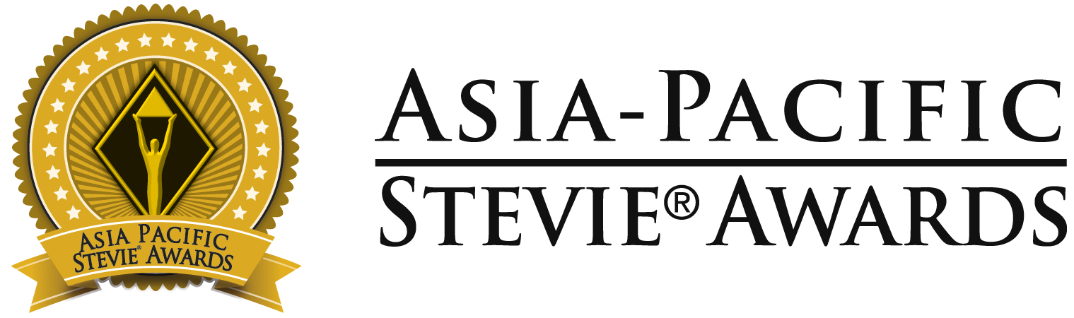

Below are optional phrases for your organization to use on social media to share the news of your Stevie Award(s).
Please tag us in your social posts as you see fit. We encourage you to follow our pages – we post features on Stevie winners throughout the year.
Asia-Pacific Stevie Awards social media: Facebook | Instagram | X | LinkedIn | YouTube

Facebook, Instagram, LinkedIn Post Option 1:

[ORGANIZATION NAME/YOUR NAME] has been recognized as a [Gold, Silver, or Bronze] winner in the 11th annual @Asia-Pacific Stevie Awards

The 2024 competition received more than 1,000 nominations from 25 nations and territories. It’s an honor to join the list of prestigious #StevieAward winners. View the full list of winners: [LINK TO WINNERS PAGE or Your Own Press Release]
#StevieAwards #StevieWinner2024

Facebook, Instagram, LinkedIn Post Option 2:

It’s an honor to be recognized as a [Gold, Silver, or Bronze] winner in the 11th annual @Asia-Pacific Stevie Awards for [YOUR CATEGORY/WINNING NOMINATION]

The Asia Stevies honors innovation in every aspect of work-life in the APAC region, from corporate communications to public relations, human resources, management, and technology. Read more about the 2024 competition and winning organizations: [LINK TO WINNERS PAGE or Your Own Press Release]
#StevieAwards #StevieWinner2024

Twitter Post Option 1:

[ORGANIZATION NAME/YOUR NAME] has been recognized as a [Gold, Silver, or Bronze] winner in the 11th @AsiaStevies! The 2024 competition received more than 1,000 nominations from 25 nations and territories. View the winning organizations: [LINK TO WINNERS PAGE or Your Own Press Release]

Twitter Post Option 2:

It’s an honor to be recognized as a [Gold, Silver, or Bronze] winner in the 11th @AsiaStevies! [YOUR CATEGORY/WINNING NOMINATION]. Read more about the 2024 competition and view the winning organizations: [LINK TO WINNERS PAGE or Your Own Press Release] #StevieAwards ##StevieWinner2024

