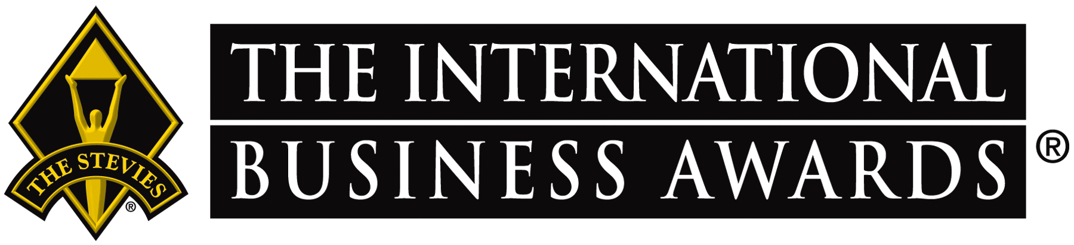
Below are optional phrases for your organization to use on social media to share the news of your Stevie® Award(s).
Please tag us in your posts as you see fit. We encourage you to follow our social media pages linked below. We post features about winners throughout the year.
LinkedIn | X | Facebook | Instagram | YouTube

Facebook, Instagram, LinkedIn Option 1:

[ORGANIZATION NAME/YOUR NAME] has been honored as a [Gold, Silver, or Bronze] @TheStevieAwards winner in The 23rd Annual International Business Awards® for [YOUR CATEGORY/WINNING NOMINATION].

More than 3,400 nominations from organizations of all sizes in 82 nations and territories were submitted this year for consideration in hundreds of categories, from Marketing Campaign of the Year to Best Entrepreneur, AI Innovation & Achievement Categories, and more. View the list of winners by category: [LINK TO WINNER LISTING PAGE or Your Own Press Release]
#StevieAwards #StevieWinner2026

Facebook, Instagram, LinkedIn Option 2:

It’s an honor to be recognized by @TheStevieAwards as a [Gold, Silver, or Bronze] winner in The 23rd Annual International Business Awards® for [YOUR CATEGORY/WINNING NOMINATIONS]

These are the world’s premier business awards. Read more about the 2026 competition and view the list of winning organizations by category: [LINK TO WINNER LISTING PAGE or Your Own Press Release]
#StevieAwards #StevieWinner2026

X Option 1:

[ORGANIZATION NAME/YOUR NAME] has been recognized as a [Gold, Silver, or Bronze] @TheStevieAwards winner in The 23rd Annual International Business Awards®. More than 3,400 nominations from organizations of all sizes in 82 nations and territories were submitted for consideration. Read more about the awards and winning organizations: [LINK TO WINNER LISTING PAGE or Your Own Press Release] #StevieAwards #StevieWinner2026

X Option 2:

It’s an honor to be recognized as a [Gold, Silver, or Bronze] @TheStevieAwards winner in The 23rd Annual International Business Awards® for [YOUR CATEGORY/WINNING NOMINATION]. Read more about the 2026 competition and winning organizations: [LINK TO WINNER LISTING PAGE or Your Own Press Release] #StevieAwards #StevieWinner2026

